**Minnesota Association of Healthcare Volunteers**

**Identity Standards Manual**

**2016**

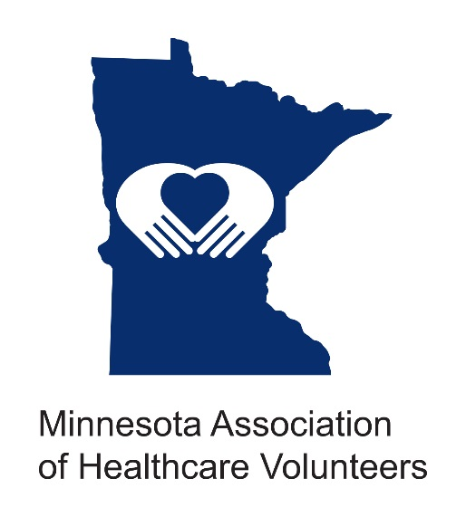

**Mission**  
The Minnesota Association of Healthcare Volunteers provides its members with opportunities to share ideas, develop leadership skills, and promote volunteer services that support Minnesota's health care facilities.  
  
**Vision**  
The Minnesota Association of Healthcare Volunteers is to be the premier leader, partner, and resource for healthcare volunteers.

**About:**

* Established in 1946 as Health Care Auxiliary of Minnesota (HCAM), under the guidance of the Minnesota Hospital Association.
* Joined by Aging Services of Minnesota in the late 60’s.
* Represent 90+ healthcare facilities in Minnesota with over 21,000 volunteers.
* Seven district chairs provide leadership to its members.

* Volunteers serve more than 1.5 million hours a year at an estimated value of more than $32 million.
* Volunteer groups fundraise and donate more than $5.5 million to their facilities each year

**Our Name**

In the fall of 2016, Health Care Auxiliary of Minnesota (HCAM) board voted to change the name and the logo to better represent that changing trends of volunteerism.

Minnesota Association of Healthcare Volunteers is the official name of the organization. It is preferred that the entire name be used rather than the acronym MAHV.

**Visibility of the Minnesota Association of Healthcare Volunteers Name**

Each volunteer and member organization is an ambassador of Minnesota Association of Healthcare Volunteers. The way we communicate with others reflects on our reputation and our identity. A good reputation, strong identity, and meaningful promise are carefully built through consistent and quality communications. This manual is a tool to help us, our vendors, and community partners consistently and accurately produce high-quality communications—it is not intended to limit or curtail creativity.

The standards and expectations contained in this manual are to be followed with the understanding that they were carefully developed to help support and develop the Minnesota Association of Healthcare Volunteers identity and reputation, and to give a consistent look and voice to our members, volunteers, partnering organizations, and the community.

**Our Logo and Its Meaning**

Minnesota Association of Healthcare Volunteers current logo was created in the fall of 2016 as a result of the organization name change from Health Care Auxiliary of Minnesota to Minnesota Association of Healthcare Volunteers.

**Logo’s Symbol:**

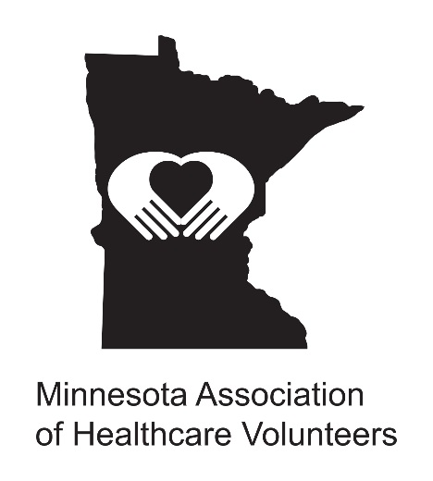

The logo’s symbol is composed of the state of Minnesota with hands encompassing a heart in the center.

The logo’s symbol can be interpreted as volunteers in healthcare offering heartfelt compassion, empathy, and care to all that they serve.

**Logo’s Color:**

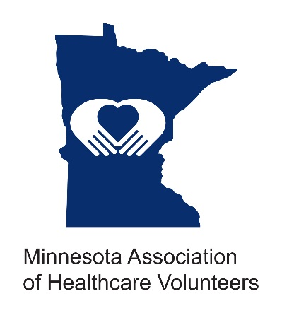

The color of the symbol is blue which is often associated with depth and stability. It symbolizes trust, loyalty, wisdom, confidence, intelligence, faith, and truth. Blue is also associated with health and healing.

**Correct Logo use**

The Minnesota Association of Healthcare Volunteers uses certain variations of its logo to guarantee that its multiple services, products, and communications are identified. *Unless approved by* *The Minnesota Association of Healthcare Volunteers Executive Board, do not use logos other* *than those specified in this manual.*

The approved logo consists of the Minnesota Association of Healthcare Volunteers symbol (graphic image) and the wordmark (our name).

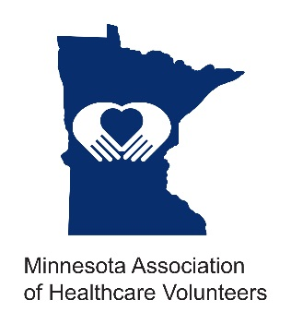

Logo

Symbol

Wordmark

The wordmark may only appear in the Arial font. Using the wordmark alone in place of the logo, without the symbol, is not permitted*. Preference is for use of the logo (symbol and wordmark together as a piece of artwork).

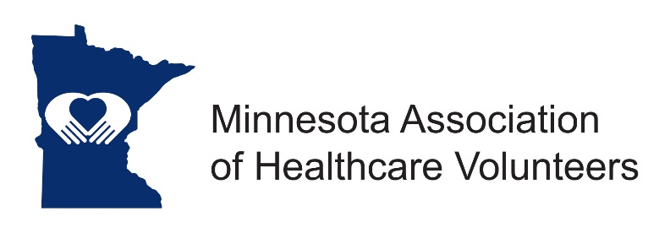

Symbol

Logo

Wordmark

**Proportional Relationship:**

Do not change the proportional relationship of the symbol to the wordmark. The symbol and wordmark should always be used together as a piece of artwork — never typeset. Do not try to reproduce the logo by placing the symbol next to a manually typed wordmark. This ensures a consistent proportion for all uses.

INCORRECT:

* Putting the wordmark over the symbol
* Just using the wordmark alone.
* Stretching the symbol horizontally or vertically

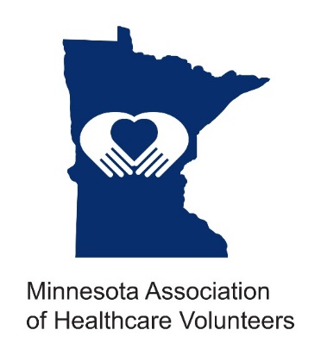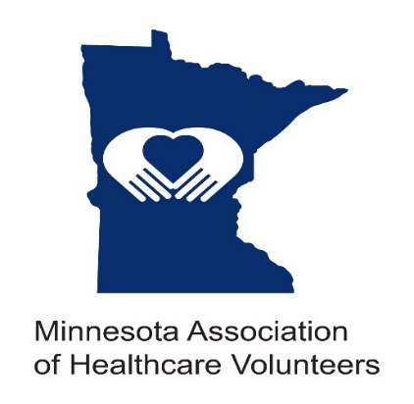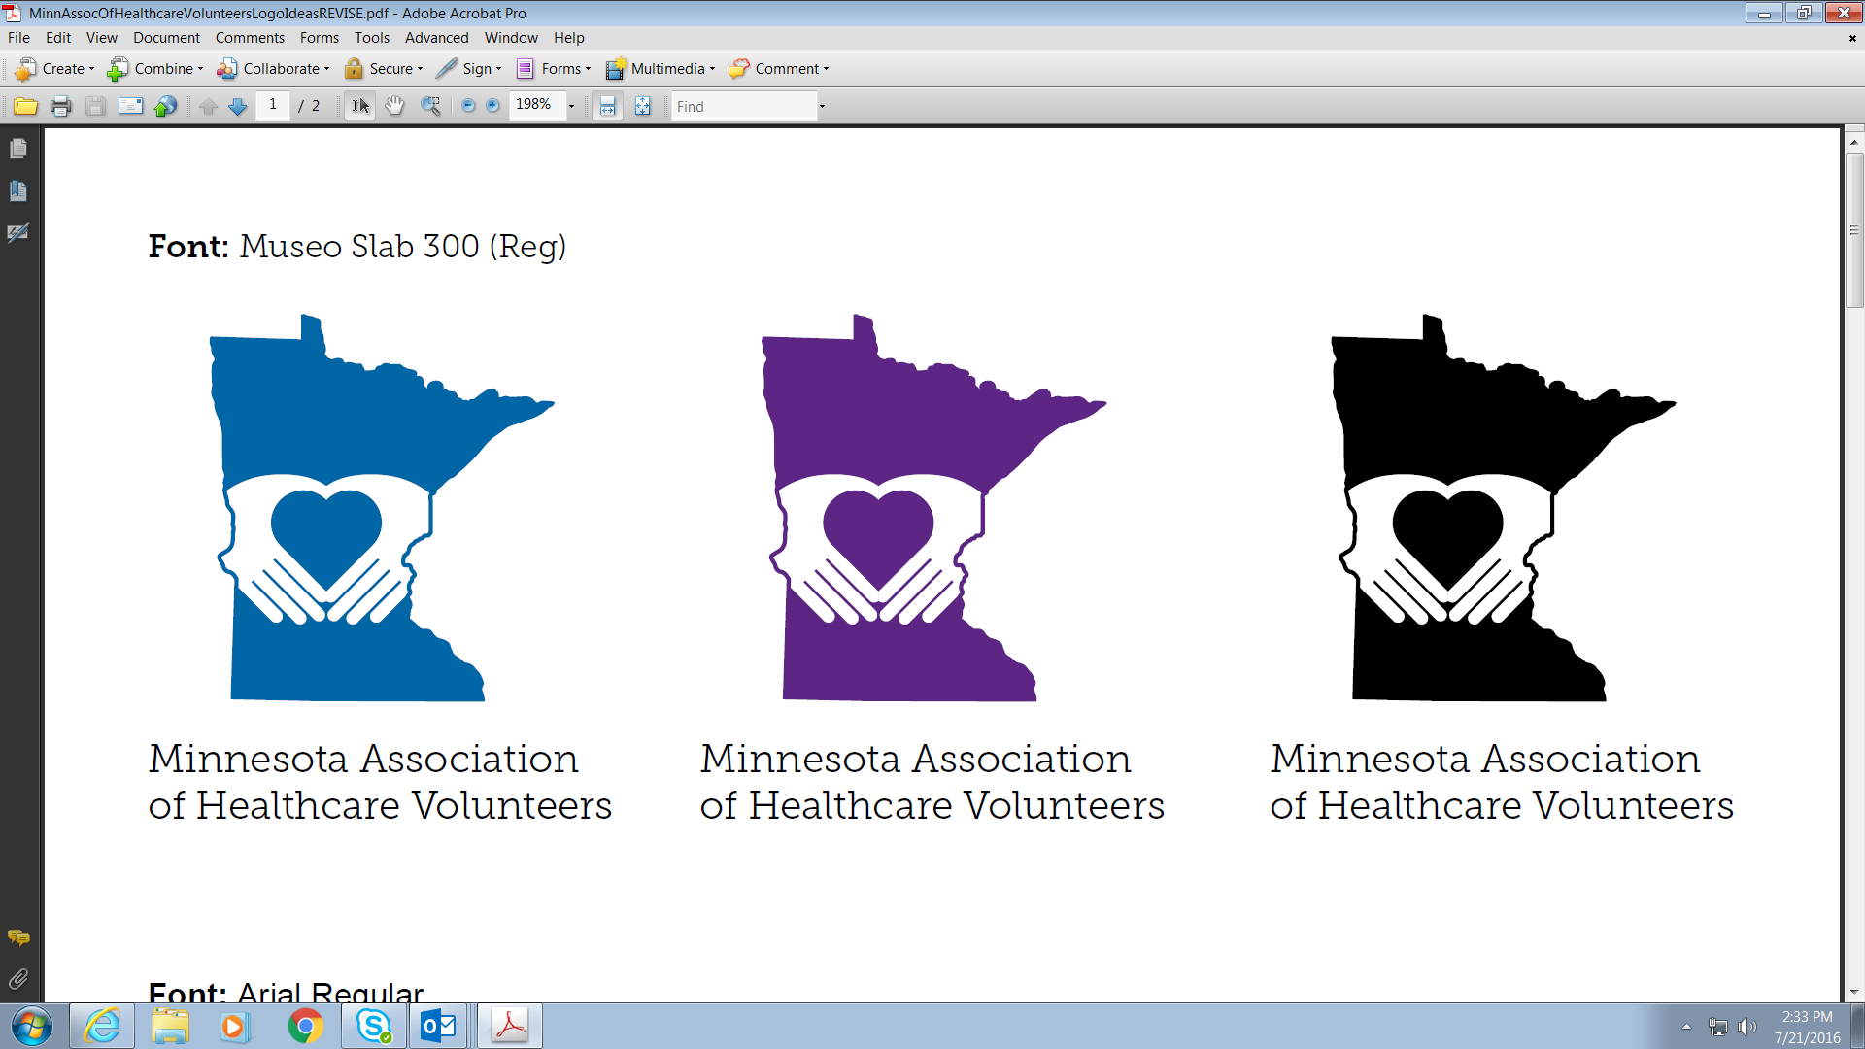 

**Acceptable Logo Variations (color options)**

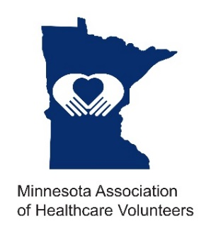

**Full-Color Logo**

Whenever possible, use the primary full-color logo of blue and black. However, when it is not possible to use the full-color logo (e.g., when the logo cannot be printed in full color), the following are acceptable alternative variations:

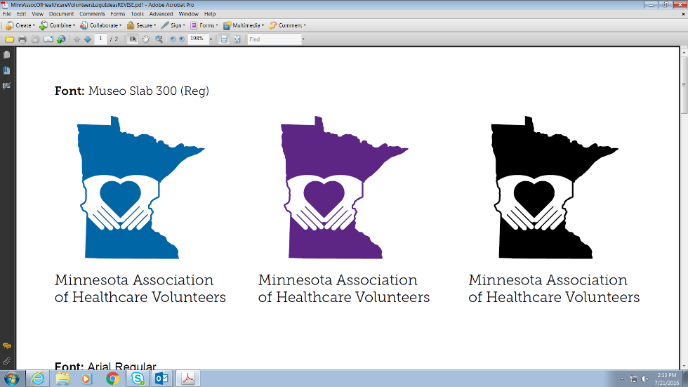**One-Color (Black) Logo**

The logo may appear in one-color, solid black. This version may be applied to white or light-colored backgrounds.

**Reversed (White) Logo**

The logo may appear reversed out (white) on a black or a dark-colored background or on a dark or non-busy section of a photograph.

**Acceptable Logo Variations (color options)**

**Stacked (vertical)**

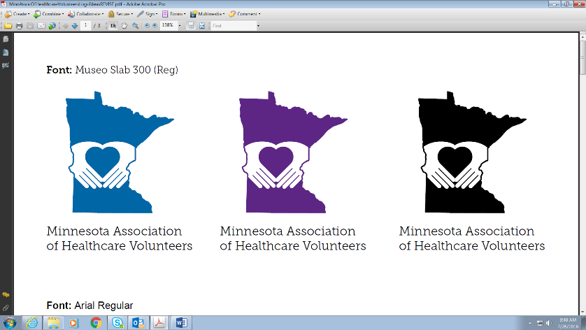

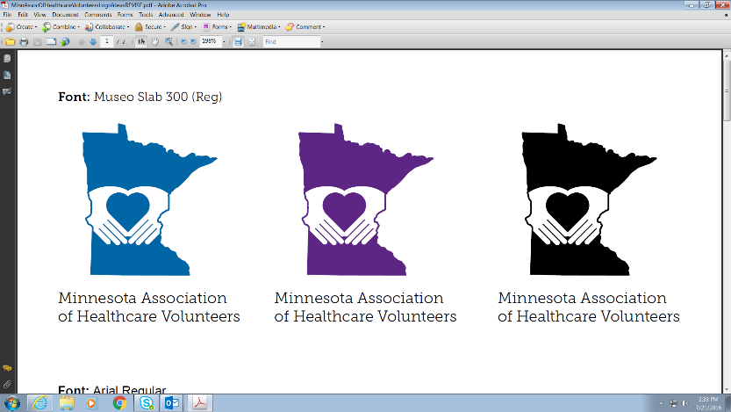

**Horizontal**

Full-Color Logo

When the preferred logo treatment cannot be used because of space restrictions, it can appear in a horizontal orientation.

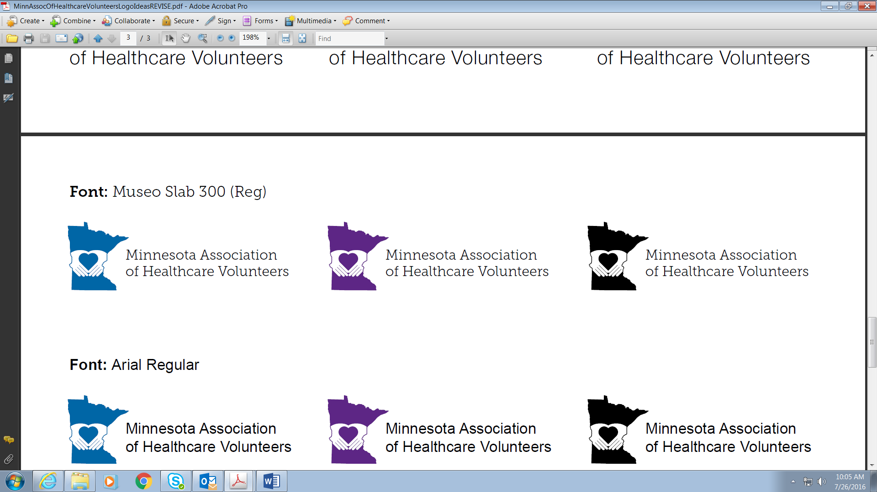

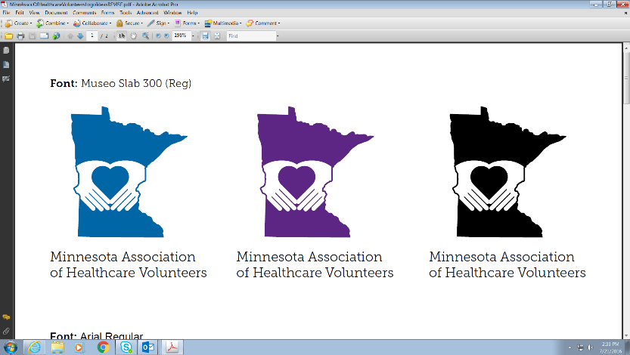Unacceptable Use of the Logo

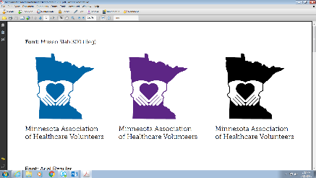Do not change the proportional relationship of the

logo in any way.

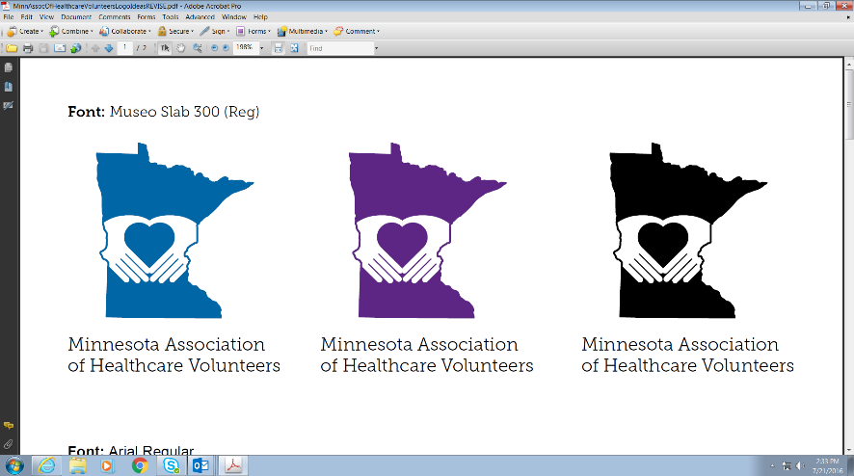

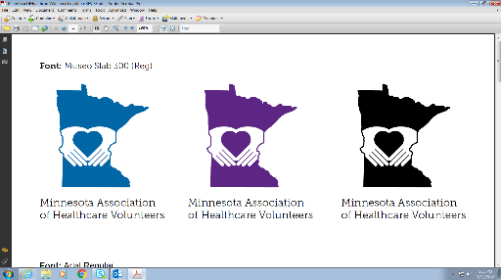

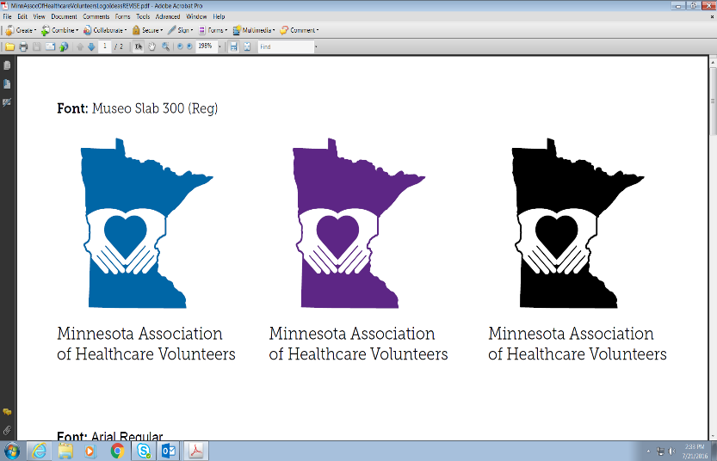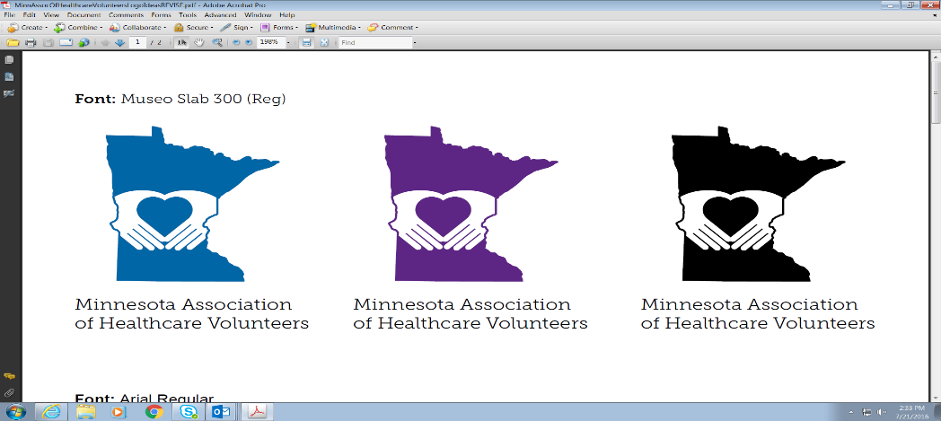

Do not condense or stretch the logo. This usually

happens when someone drags the sides of the logo

(instead of the corners) to change its size.



Do not rotate the logo.

Do not change the color or convert to grayscale

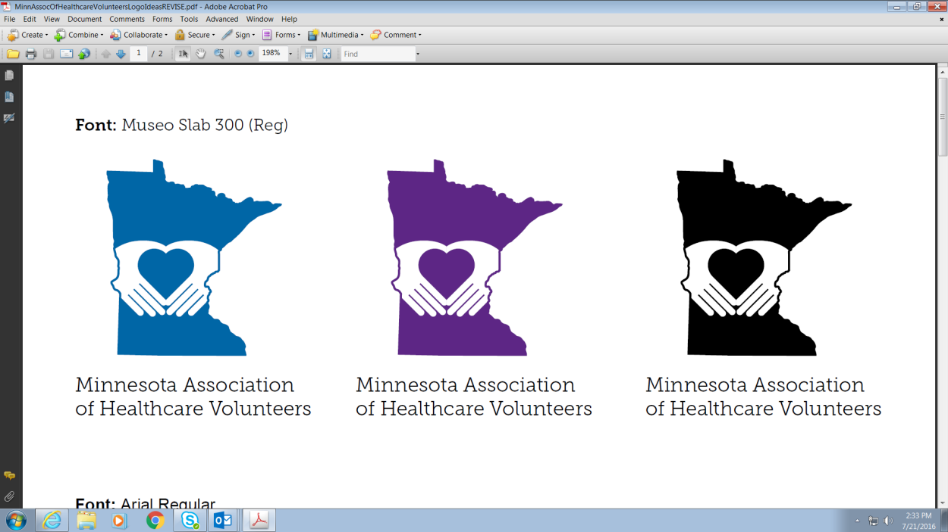Do not use the wordmark without the symbol

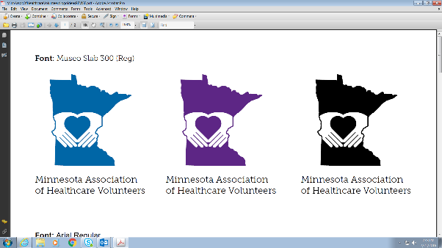

Do not place the logo in a shape that could be

considered part of the logo.

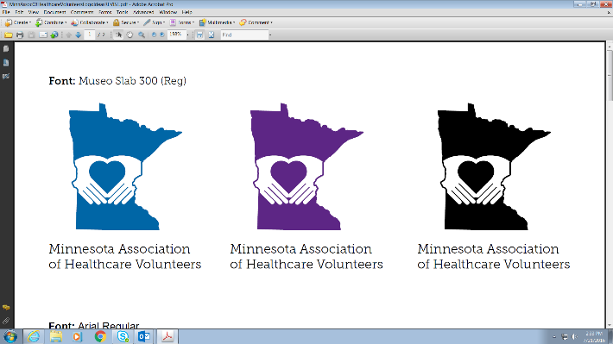

Do not reverse or place the logo on a patterned

background or busy photograph



Do not give the logo a shadow