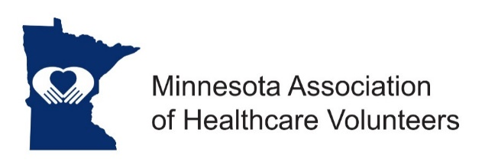

Administrators of Healthcare Volunteers (AHV) Liaison Position Description

Minnesota Association of Healthcare Volunteer’s mission is to provide members with opportunities to share ideas, develop leadership skills, and promote volunteer services that support Minnesota’s health care facilities.

Minnesota Association of Healthcare Volunteers vision is to be the premier leader, partner, and resource for healthcare volunteers and auxilians.

The AHV Liaison serves as a link between members of AHV and the Minnesota Association of Healthcare Volunteers (MAHV).

Term
The AHV Liaison position is appointed by the President. Term of office begins at the November Board Meeting.

Responsibilities
- Reports to the MAHV Leadership Board on AHV activities that align with MAHV’s mission and serves its members
- Reports to AHV Leadership Committee about MAHV activities that align with AHV’s purpose and serves its members
- Seeks out opportunities for collaboration including cross-promoting education, resources and membership.
- Actively promotes MAHV membership to AHV members.
- Serves on Conference and Annual Meeting program committee to implement Volunteer Administrator educational programs specific to their needs.

Expenses
Expenses will be reimbursed consistent with the current Standing Rules.

Qualifications
- Knowledge of and commitment to the mission and vision of the Minnesota Association of Healthcare Volunteers
- Active member of both organizations.
- Willing to commit time and travel
- Written and oral communication skill
- Technology expertise

Benefits
Satisfaction that comes with service
Opportunities for personal growth and development
10/2018

