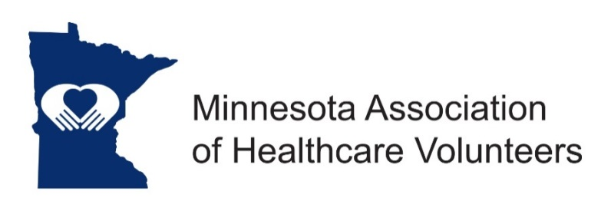
Data Manager - Position Description

Minnesota Association of Healthcare Volunteer’s mission is to provide members with opportunities to share ideas, develop leadership skills, and promote volunteer services that support Minnesota’s health care facilities.

Minnesota Association of Healthcare Volunteers vision is to be the premier leader, partner, and resource for healthcare volunteers and auxilians.

The Data Manager is responsible for collecting and keeping membership lists current.

Term
The Data Manager is appointed by the President to serve under his/her direction for a two year term.

Responsibilities
- Send dues and survey data form notices to Minnesota Association of Healthcare Volunteer members in collaboration with Membership
- Send all dues payments to Treasurer for deposit
- Maintain a current list of the organizations’ members
- Compile survey information provided by member organizations
- Send membership and survey information to the Leadership Board and Website Manager
- Collaborate with Membership to ensure accurate membership information
- Maintain email addresses: send by email all material, with presidential approval, as requested by Minnesota Association of Healthcare Volunteers board members.

Expenses
Expenses will be reimbursed consistent with the current Standing Rules

Qualifications
- Knowledge of and commitment to the mission and vision of the organization
- Willing to commit time and travel
- Written and oral communication skill
- Technology expertise (e-mail, document preparation, spreadsheets, etc)
- Have an active internet connection

Benefits
- Satisfaction that comes with service
- Opportunities for personal growth and development

Time Commitment
Monthly/Ongoing
- Work closely with Membership to keep membership records up to date, including lists of past members, current members, and potential members
- Receive and record dues and survey data information: send dues payments to the Treasurer
- Inform the Leadership Board when dues and surveys are received from a new member
- Attend District Spring and Fall Meetings and Legislative Day when able

December/January
- Create mailing lists and send dues notices and data survey forms to members

February/March
- Send (or call) members who have not paid their dues
- Collaborate with the Membership on strategies to collect dues
- Prepare membership report for the next Leadership Board Meeting

Summer
- Prepare report summarizing members by districts, and data to include numbers of volunteers, volunteer hours, dollars raised
- Present annual membership report to the Conference Committee

September
- Attend Annual Conference, if possible
- Review position description
- At the end of term, pass along all records/books to the new Data Manager

November
- Attend November Leadership Board Meeting/Training

10/2018

