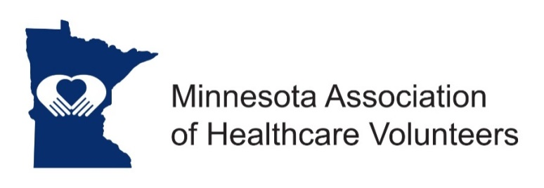
Heart of MN Awards Chairman Position Description

Minnesota Association of Healthcare Volunteer’s mission is to provide members with opportunities to share ideas, develop leadership skills, and promote volunteer services that support Minnesota’s health care facilities

Minnesota Association of Healthcare Volunteers vision is to be the premier leader, partner, and resource for healthcare volunteers and auxilians

The Heart of Minnesota Award Committee Chair directs and manages the process for choosing recipients of the Heart of Minnesota Awards - given annually.

Term
The Heart of Minnesota Award Committee Chair is appointed from the membership by the President. The position is eligible for re-appointment. Term of office begins at the November Board Meeting.

Responsibilities
- Direct and manage the process for choosing recipients of the Heart of Minnesota Awards including:
  - Criteria and timeline
  - Award publicity
  - Nomination process
  - Selection process
  - Award presentation
  - Award recipients recognition
- Organize and support a committee structure to ensure a fair process
- Evaluate and continuously improve the Heart of Minnesota Award process
- Keep portfolio of work to pass along to the successor

Expenses
Expenses will be reimbursed consistent with the Standing Rules to include expenses for application process and awards.

Qualifications
- Knowledge of and commitment to the mission and vision of HCAM
- Organizational leadership experience
- Willing to commit time and travel if needed
- Excellent written and oral communication skill
- Technology expertise (e-mail, document preparation)

Benefits
- Satisfaction that comes with service
- Opportunities for personal growth and development

Time Commitment

November/January/February
February
- Research options for printing Award Nomination materials
- Revise and have Award Nomination materials printed
- Request address labels from the Data Manager

March
- Prepare and send Committee Report for the Board Meeting
- Prepare letters to Auxiliary and Volunteer Organization Presidents

April
- Mail nomination materials to Auxiliary and Volunteer Organization Presidents, using e-mail/technology, if possible
- Post nomination materials on the Website

June
- Prepare and send Committee Report to the Board
- Receive award nominations

July
- Select judges
- Mail packets to judges, using technology, if possible

August
- Receive and tabulate judge’s results
- Notify award recipients (contact auxiliary or volunteer group President of award recipients to determine the preferred way to notify the winners; follow up with a phone call or formal letter)
- Send letter of regret to all who were unsuccessful with their nominations
- Order awards

September
- Attend Annual Meeting and Conference if possible
- Prepare and send Committee Report to the Board
- Assist the President in presenting awards at the Annual Meeting, or arrange a suitable venue for award presentation
- Prepare a script for the President to use for presentation
- Publicize the award recipients as appropriate

10/2018

