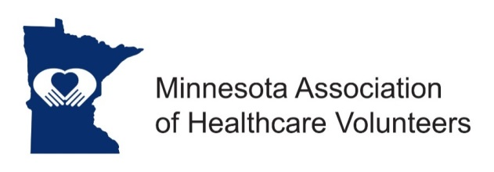
Historian Position Description

Minnesota Association of Healthcare Volunteer’s mission is to provide members with opportunities to share ideas, develop leadership skills, and promote volunteer services that support Minnesota’s health care facilities.

Minnesota Association of Healthcare Volunteers vision is to be the premier leader, partner, and resource for healthcare volunteers and auxilians.

The Historian collects and preserves the history of the Minnesota Association of Healthcare Volunteers.

Term
The Historian is appointed by the President. Term of office begins at the November Board Meeting.

Responsibilities
- To collect all past materials from previous historian
- Keep the history of the organization in story or file form including facts, events, dates, and other data which indicate the progress of the Minnesota Association of Healthcare Volunteers
- Organize and keep up to date the following materials: minutes, reports, notes, programs, brochures, flyers, new clippings and pictures, all relating to the Minnesota Association of Healthcare Volunteers activities.
- Enlist help of board and committee members for gathering data
- Attend and support all functions of the organization whenever possible

Expenses
Expenses will be reimbursed consistent with the current Standing Rules.

Qualifications
- Knowledge of and commitment to the mission and vision of the Minnesota Association of Healthcare Volunteers
- Organizational leadership experience
- Willing to commit time and travel
- Written and oral communication skill
- Technology expertise (e-mail, document preparation)

Benefits
Satisfaction that comes with service
Opportunities for personal growth and development

10/2018

