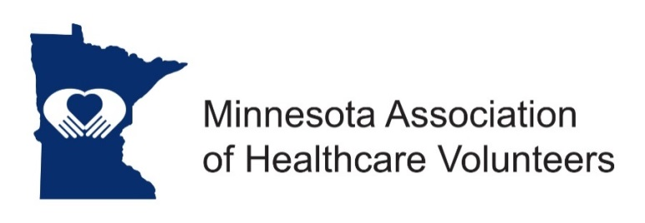
Legislative Advocacy Position Description

Minnesota Association of Healthcare Volunteer’s mission is to provide members with opportunities to share ideas, develop leadership skills, and promote volunteer services that support Minnesota’s health care facilities

Minnesota Association of Healthcare Volunteers vision is to be the premier leader, partner, and resource for healthcare volunteers and auxilians

The Legislative Advocacy Chairman and committee members work with the Minnesota Hospital Association (MHA) and LeadingAge MN to plan and promote the Minnesota Association of Healthcare Volunteers’ Legislative Day at the Capitol, and to support the advocacy agenda of the Minnesota Hospital Association and LeadingAge MN.

Term
The Legislative Advocacy Chair is appointed by the President. Term of office begins at the November Board Meeting.

Responsibilities
- Plan and promote the Minnesota Association of Healthcare Volunteers’ Legislative Day at the Capitol
- Take leadership for supporting the advocacy agendas of the Minnesota Hospital Association and LeadingAge MN
- Seek partnership opportunities to promote and expand advocacy
- Attend Leadership Board Meetings and other meetings, as requested by the President

Expenses
Expenses will be reimbursed consistent with the current Standing Rules to include expenses for Legislative Day.

Qualifications
- Knowledge of and commitment to the mission and vision of the organization
- Organizational leadership experience
- Willing to commit time and travel
- Written and oral communication skill
- Technology expertise (e-mail, document preparation)

Benefits
Satisfaction that comes with service
Opportunities for personal growth and development

Time Commitment

November
- Attend Board Meeting
- Prepare, send, and present Advocacy Report at the Board Meeting
- Write and send advocacy article for the Website
- Prepare and disseminate “save the date” information for Legislative Day
- Confirm hotel and catering for Legislative Day
- Confirm speakers for Legislative Day

December/January/February
- Prepare and send marketing materials for Legislative Day
- Organize registration process for Legislative Day
- Prepare and send Advocacy Report for Board Meeting, if scheduled
- Monitor Legislative Session and send action alerts to the Board, as appropriate
- Write and send advocacy article for the Website

March
- Prepare and send Advocacy Report for the Board Meeting.
- Seek assistance from MHA and LeadingAge MN with making appointments for legislative visits for those attending Legislative Day
- Convene and enjoy Legislative Day
- Recognize all who help make Legislative Day happen
- Prepare Legislative Day evaluation report, send to the Board
- Continue to monitor Legislative Session and send action alerts to the Board and membership

May
- Continue to monitor Legislative Session and send action alerts to the Board and membership

June
- Prepare and send Advocacy Report for the Board Meeting to include a summary and evaluation of Legislative Day
- Set date for the next Legislative Day with MHA and LeadingAge MN
- Reserve hotel and catering for the next Legislative Day

September
- Attend if possible the Conference and Annual Meeting
- Prepare and send Advocacy Report for the Board Meeting

