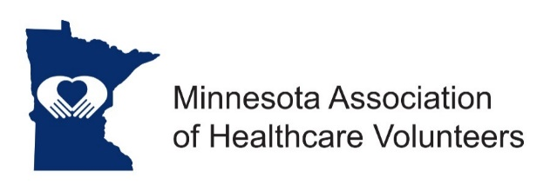
Marketing & Communication Chair Job Description

Minnesota Association of Healthcare Volunteer’s mission is to provide members with opportunities to share ideas, develop leadership skills, and promote volunteer services that support Minnesota’s health care facilities.

Minnesota Association of Healthcare Volunteers vision is to be the premier leader, partner, and resource for healthcare volunteers and auxilians.

The Marketing and Communication Chair will be responsible for leading a committee that will oversee the coordination of all marketing activities for the Minnesota Association of Healthcare Volunteers. The Chair will recruit, with the assistance of the board, people with the skill sets needed.

Term
The Communications and Marketing position is appointed by the President. Term of office begins at the November Board Meeting.

Responsibilities
- Coordinate and work closely with the Leadership Board
- Coordinate and work closely with the webmaster in the communication process
- Coordinate and work closely with the Membership Chair and/or District Chairs
- Design/develop recruitment materials
- Develop marketing tools and a marketing plan

Expenses
Expenses will be reimbursed consistent with the current Standing Rules.

Qualifications
- Knowledge of and commitment to the mission and vision of the Minnesota Association of Healthcare Volunteers
- Marketing and/or graphic design experience
- Willing to commit time and travel
- Written and oral communication skill
- Technology expertise

Benefits
Satisfaction that comes with service
Opportunities for personal growth and development

10/2018

