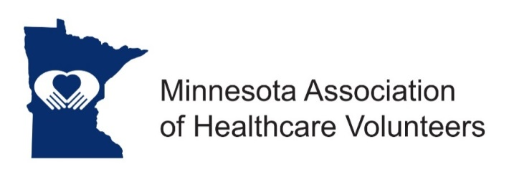
Parliamentarian Position Description

Minnesota Association of Healthcare Volunteer’s mission is to provide members with opportunities to share ideas, develop leadership skills, and promote volunteer services that support Minnesota’s health care facilities

Minnesota Association of Healthcare Volunteers vision is to be the premier leader, partner, and resource for healthcare volunteers and auxilians

The Parliamentarian advises the President, Board and Committee members on matters of parliamentary procedure.

Term
The Parliamentarian is appointed from the membership by the President. Term of office begins at the November Board Meeting.

Responsibilities
- Attend all Leadership Board Meetings and other meetings as requested by the President; serves as a non-voting member of the Leadership Board
- Advise the President and other board and committee members on matters of parliamentary procedure, using the latest version of Robert’s Rules of Order
- Be familiar with the Minnesota Association of Healthcare Volunteers Bylaws and standing rules, and advise the Board when business is out of order
- Serve on the committee to review the organization’s Bylaws
- Keep portfolios of work to pass along to the successor
Expenses
Expenses will be reimbursed consistent with the current Standing Rules to include expenses for Board Meetings and other meetings as requested by the President. The Parliamentarian can also expense the latest version of Robert’s Rules of Order, when a new version is available.
Qualifications
- Knowledge of parliamentary procedure
- Knowledge of and commitment to the mission and vision of Minnesota Association of Healthcare Volunteers
- Organizational leadership experience
- Willing to commit time and travel
- Written and oral communication skills
- Technology expertise (e-mail, document preparation)
Benefits
- Satisfaction that comes with service
- Opportunities for personal growth and development

Time Commitment
- Assist the President with preparations for the Annual Meeting
- Attend and serve as Parliamentarian at the Annual Meeting. Board Meetings and other meetings at the request of the President.
- Prepare script for president to conduct election of officers at the annual meeting

