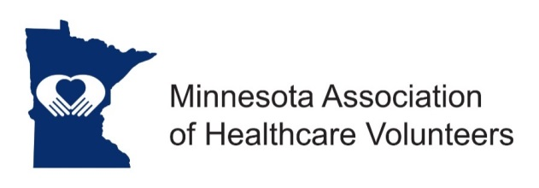
Past President Position Description

Minnesota Association of Healthcare Volunteer’s mission is to provide members with opportunities to share ideas, develop leadership skills, and promote volunteer services that support Minnesota’s health care facilities.

Minnesota Association of Healthcare Volunteers vision is to be the premier leader, partner, and resource for healthcare volunteers and auxilians.

The Past President serves as advisor to the President and oversees other Committees as appointed by the President.

Term
The Past President’s term is for one year and begins at the November Board Meeting.

Responsibilities
- Serve as advisor to President and Board when asked and assist them as needed.
- Support the new President, while allowing him/her to develop personal management style.
- Chair the Nominating Committee and other committees as appointed by the President
- Attend all Leadership Meetings and other Minnesota Association of Healthcare Volunteers functions.
- Review and if necessary, revise position descriptions.

Expenses
Expenses will be reimbursed consistent with the current Standing Rules.

Qualifications
- Knowledge of and commitment to the mission and vision of the Minnesota Association of Healthcare Volunteers
- Organizational leadership experience
- Willing to commit time and travel
- Written and oral communication skill
- Technology expertise (e-mail, document preparation)

Benefits
Satisfaction that comes with service
Opportunities for personal growth and development

10/2018

