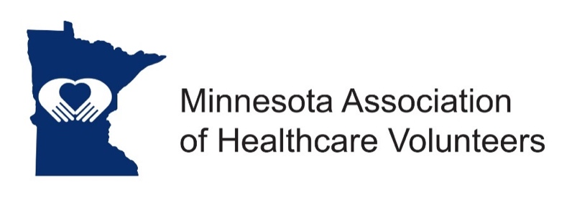
Website Manager - Position Description

Minnesota Association of Healthcare Volunteer’s mission is to provide members with opportunities to share ideas, develop leadership skills, and promote volunteer services that support Minnesota’s health care facilities.

Minnesota Association of Healthcare Volunteers vision is to be the premier leader, partner, and resource for healthcare volunteers and auxilians.

The Website Manager is responsible for keeping the Minnesota Association of Healthcare Volunteers website and social media sites current and active.

Term
The WEB Manager is appointed by the current President to serve under his/her direction.

Responsibilities

- Keep all information up to date on the website on a daily or at least weekly basis
- Maintain and update documents residing on the website
- Promote use of the website
- Work closely with a web consultant as needed

Expenses
Expenses will be reimbursed consistent with the current Standing Rules

Qualifications

- Knowledge of and commitment to the mission and vision of the organization
- Written and oral communication skill
- Advanced knowledge of computers and website development and administration
- Technology expertise (e-mail, document preparation, social media)
- Have an active internet connection

Benefits

- Satisfaction that comes with service
- Opportunities for personal growth and development

Time Commitment

Monthly/Ongoing
- Work closely with the Leadership Board and Committees to collect current information for the website.
- Keep the website updated with all information received from the Board and Districts

