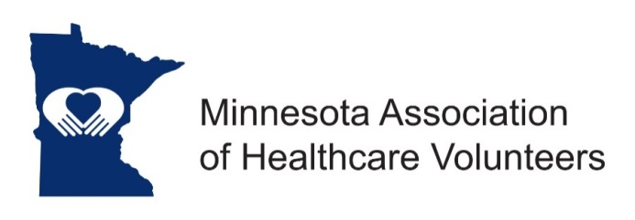
President-Elect Position Description

Minnesota Association of Healthcare Volunteer’s mission is to provide members with opportunities to share ideas, develop leadership skills, and promote volunteer services that support Minnesota’s health care facilities.

Minnesota Association of Healthcare Volunteers vision is to be the premier leader, partner, and resource for healthcare volunteers and auxilians.

The President-Elect assists and supports the President, and performs the duties of the President in the President’s absence.

Term
The President-Elect is elected at the Annual Meeting to serve one term followed by one term as President, followed by one term as Past President. Term of office begins at the Annual Meeting/installation.

Responsibilities
- Assist and support the President
- Learn duties of the President
- Attend all meetings of the Board, and other meetings as requested by the President
- Attend fall and spring district meetings as requested by the President
- Develop goals and a plan for the following term

Expenses
All approved/reasonable expenses incurred by the President-Elect will be paid by Minnesota Association of Healthcare Volunteers per the current Standing Rules and other expenses associated with meetings requested by the President.

Qualifications
- Knowledge of and commitment to the mission and vision of the Minnesota Association of Healthcare Volunteers
- Organizational leadership experience
- Willing to commit time and travel
- Written and oral communication skill
- Technology expertise (e-mail, document preparation)

Benefits
Satisfaction that comes with service
Opportunities for personal growth and development

Time Commitment

September
- Attend September Board Meeting
- Attend Annual Conference/Meeting
- Make arrangements to attend Fall District Annual Meetings as scheduled

October
- Attend Fall District Annual Meetings as requested by the President
  - Coordinate travel and accommodations if requested by the President
  - Identify future Board leadership at district meetings

November
- Attend November Board Meeting
- Assist the President as requested

January
- Attend January Board Meeting, if scheduled

February
- Assist the President with planning Spring District Forums

March
- Attend Board Meeting/Legislative Day, Assist the President as requested
- Make arrangements to attend scheduled Spring District Forums
- Help President prepare education module to present at District Forums

April
- Register and make arrangements to attend State Auxiliary Leaders meeting and American Hospital Association meetings in Washington DC (Optional)
- Attend District Spring Forums as scheduled
  - Coordinate travel and accommodations if requested by the President
  - Identify future Board leadership at district meetings

May
- Attend SAL/AHA meetings in Washington DC if designated

June
- Attend Board Meeting, Assist the President as requested

July-August
- At end of term:
  - Work with the Membership Chair to determine next year’s calendar
  - Develop leadership priorities to propose to the Board
  - Prepare acceptance speech for Annual Meeting
  - Order gifts for outgoing board members if applicable

10/2018

