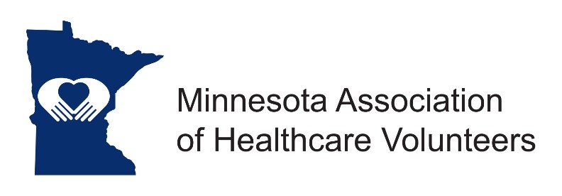

MAHV Board Meeting
November 10, 2021

The Minnesota Association of Healthcare Volunteers Leadership Board met on Wednesday, November 10, 2021 Via Zoom at 9:00 to 11:00

Leadership Board in Attendance: Jane Denovchek, Bev Moberg, Jody Bjerke, Janene Riedeman, Marlene Smith, Linda Tezak, Phyllis Ducey (non-Voting).

Additional invited participants: Theora Goodrich, Iliose Groth, Kelly Owens, and Karen Skarphol.

Our Mission is to provide our members with opportunities to share ideas, develop leadership skills, and promote volunteer services that support Minnesota’s health care facilities.

Our Vision is to be the premier leader, partner, and resource for health care volunteers.

There were no additions to the Agenda, and a quorum was verified.

Accomplishments in 2021 – President Jane Denovchek
- Fifteen e-newsletters were sent
- 48 MAHV-elous Awards for Outstanding Volunteers were given
- 2021 Membership dues were waived
- Membership dues were reduced for 2022
- Made the renewal process easier
- Virtual Forums were held with a Keynote speaker for the Fall Forum
- Two free Webinars with a Keynote speaker were held
- A Regional Fall Conference was held with excellent attendance
- Affiliation was re-established with MHA (Minnesota Hospital Association)
- A new Module was created, based on Bev’s fall forum presentation “Unstoppable Volunteers”

President’s Thoughts – Jane Denovchek
We still have some open spots to fill on this board. We need a President Elect – hopefully someone with some technical skills; Secretary; Web Page; (Phil Ruggiero is doing it for the present); and someone to take over the Heart of Minnesota Awards.

Secretary’s Report – Marlene Smith
There were not corrections so the report will be filed.

Fall Conference – Kelly Owens
- We had a Virtual Regional Conference which included Minnesota, Iowa, Wisconsin, and North Dakota.
- We had 135 in attendance at the Conference with a $3,400 profit. This amount will be set aside for another Regional Conference. (If no future Conference, it will be divided between the 4 states)
- The Planning Committee will be meeting again soon.
- Kelly asked if we are wanting another Virtual Regional Fall Conference or just a State Conference.
- It was an excellent Conference with exceptional Speakers.
- A virtual conference is less expensive and we get much more participation.
- Kelly and Jody were given a sincere Thank-You for their work for the Conference.
- Iowa and Wisconsin are Hospital Based, set up a little different than Minnesota and North Dakota.

Membership/District – Linda Tezak
- Karen Skarphol, Windom Area Hospital Auxiliary, was introduced as the new Chair for District E.
- Spring and Fall Forum Hosts are being chosen.
- We need to contact our Representatives to push for them to give the Front Line Workers Pay to Health-care workers.
- In-person meetings are preferred, but we may need to be Virtual again this year.
- Spring District Forums are suggested to be held during the last two weeks of April in 2022.

Budget – Jody Bjerke
- Jody presented the approved budget.
- The bank required some things to be updated which Jody has done.
- The deficit budget balance was discussed with some suggestions how to avoid this.
- Motion by Jody Bjerke, second by Linda Tezak to take Ray Kuntz’ name off the Credit Card, and put Bev Moberg on the Credit Card and the Banking account. Motion carried.

Awards – Bev and Jane
- There were no nominations for the Heart of Minnesota Awards, probably because of Covid.
- Jane and Theora will work on making some changes to the process.
- Jane will give the President’s award at the Annual Meeting on December 8th.

Discussion – Bev and Jane
- Reconnect, it is difficult to get volunteers back in some areas.
- Round Tables to target new coordinators and officers.
- Welcome – a packet or some means to share information for new leaders.

Goals/Priorities – Bev
- Communicating/building relationships with CEOs
- Round Tables

* Training/Communication at the local and district level

* Virtual meetings with District Chairs
Send Off
- Theora shared her presentation of “Be a Pineapple”

* Stand up Tall – look people in the eye

* Wear a Crown – value yourself

* Be Sweet – use your mouth for kindness and encouragement

The meeting was adjourned at 11:00 a.m.

Marlene Smith, Secretary

