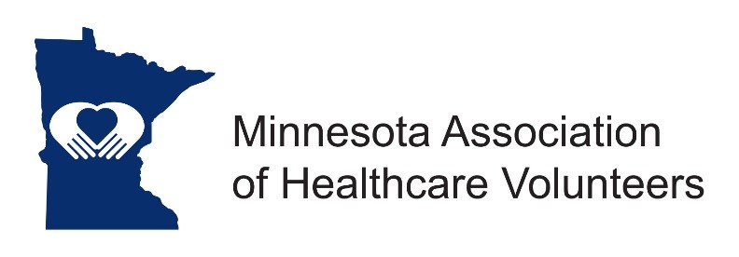

MAHV Board Meeting
June 14, 2023

The Minnesota Association of Healthcare Volunteers Leadership Board met on Wednesday, June 14, 2023 at 10:00 am and held at the Gorecki Guest House in St. Cloud.

Leadership Board in Attendance: Bev Moberg, Jane Denovchek, Jody Bjerke, Marlene Smith, Janene Riedeman. Absent: Linda Tezak.

Additional invited participants: Theora Goodrich, Phil Ruggiero, and Meeting Facilitator Meg Swenson of Coaching Brilliance.

Our Mission is to provide our members with opportunities to share ideas, develop leadership skills, and promote volunteer services that support Minnesota’s health care facilities.

Our Vision is to be the premier leader, partner, and resource for health care volunteers.

Agenda: There were no additions to the Agenda.

Introductions: Each attendee briefly introduced themselves and was asked to briefly state their thoughts on this Organization continuing or dissolving.

ITEMS DISCUSSED

Reasons to continue:
- We have been in existence for 75 years.
- Volunteers continue to be an important part of Healthcare.
- We offer excellent education opportunities.
- We offer networking and connections.
- Leadership is an important Key to this organization.

Who do we serve:
- We probably are more effective and needed in the rural communities

Recruitment:
- Are we inviting others to join the organization? How are we inviting others to join the Leadership team?
- We had 101 members and now we only have 36 members.

Districts:
- District A and District D each have a Chair.
- District B has an acting Chair.
- District C, E, and F are without Chairs.
- We need leaders if we are to remain viable.
Dissolving Procedures:
- Once we file to dissolve there is no backing out, and there is a specific process to follow.
- Are we wanting to consider this?

Technology:
- In todays world, networking is prime, and modern technology allows us to do this.
- Would we be willing to pay someone to setup a Network Hub?
- Janene Riedeman offered to formulate a plan for a fee. She will present this in a month.
- Discussion followed about paying a stipend for Janene or someone to do the technology plan.
- Motion by Jody, second by Jane to have a time table, and a virtual meeting to review proposals and make decision on Tuesday July 18, 2023 at 11:00 am. Motion carried.

Officers willing to continue:
- President – none
- President Elect – none
- Secretary – Marlene Smith
- Treasurer – Jody Bjerke
- Membership Chair – Linda Tezak

Continue or Dissolve?
- Consensus is to continue at this time. Final decision to be made at a later date.

Treasurers Report: Jody Bjerke
- Jody presented the budget.
- District A and District F requested some financial assistance for their district meetings.
- Bev was reimbursed for her mileages.

Presentations:
- Bev presented Past President Jane Denovchek with the MAHV-elous Award.
- Bev presented Secretary Marlene Smith with the MAHV-elous Award.
- Bev presented Treasurer Jody Bjerke with the MAHV-elous Award.
- Bev presented Theora Goodrich with the MAHV-elous Award.
- Bev presented Phil with the MAHV-elous Award.
- Bev will see that Membership Chair Linda Tezak gets her MAHV-elous Award.

Upcoming Events
- Tuesday July 18, 2023 10:00 MAHV Board Meeting (Virtual)
- Tuesday September 12, 2023 10:00 am Webinar
- Wednesday November 15, 2023 MAHV Board Meeting (Virtual)
- Thursday December 7, 2023 10:00 am - Annual meeting.

Bev adjourned the meeting at 1:00 p.m.

Marlene Smith, Secretary

