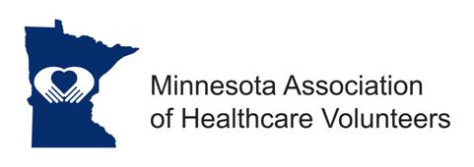
2024 MAHV Dues Invoice

Options for Completing:
- Print form and fill out. Send to Jody Bjerke (information below).
- Fill out as a fillable form (click on gray box, type answer, tab or move to next box, type, etc., once done, save on your computer and send as an attachment to Jody Bjerke (email below).

Name of facility:
Facility Address: State: Zip Code:
Type of facility: Hospital Long-Term Care Other:

Do you have an Auxiliary?
Yes Name of Auxiliary:
Name of Auxiliary President: Phone:
President Address: State: Zip Code:
E-mail:

No Name of Volunteer Group:
Name of Volunteer Manager/Coordinator/Director:
Address: Same as facility address above. Phone:
Other Address: State: Zip Code:
E-mail:

Dues for 2023:
We are a new member organization (no charge) with (number) volunteers.
We are a current member organization with the following number of volunteers.
25 > ($50.00) How many volunteers do you have?
<25 ($25.00) How many volunteers do you have?

Choose the MAHV district you are in:
A (NW) B (NE) C (West Central) D (East Central E (SW) F (SE) G (Metro)

Payment:
Total amount to be paid:
Check (made payable to Minnesota Association of Healthcare Volunteers)
Credit card (if you do not feel comfortable entering credit card # below, please contact Jody Bjerke)
- Credit Card #: CVV (3-digit code on back of card) Expiration Date: Zip Code (card holder): ______________
- Signature (please sign or initial)
- Email to send receipt:

Return by March 1, 2024, to:
Jody Bjerke, MAHV Treasurer | 26975 Lake Ethel Road, Battle Lake, MN 56515 jody.mahv@gmail.com.

